Design Patterns extra1
Microservices Design Patterns | Microservices Architecture Patterns | Edureka
https://www.youtube.com/watch?v=xuH81XGWeGQ

Aggegater Pattern

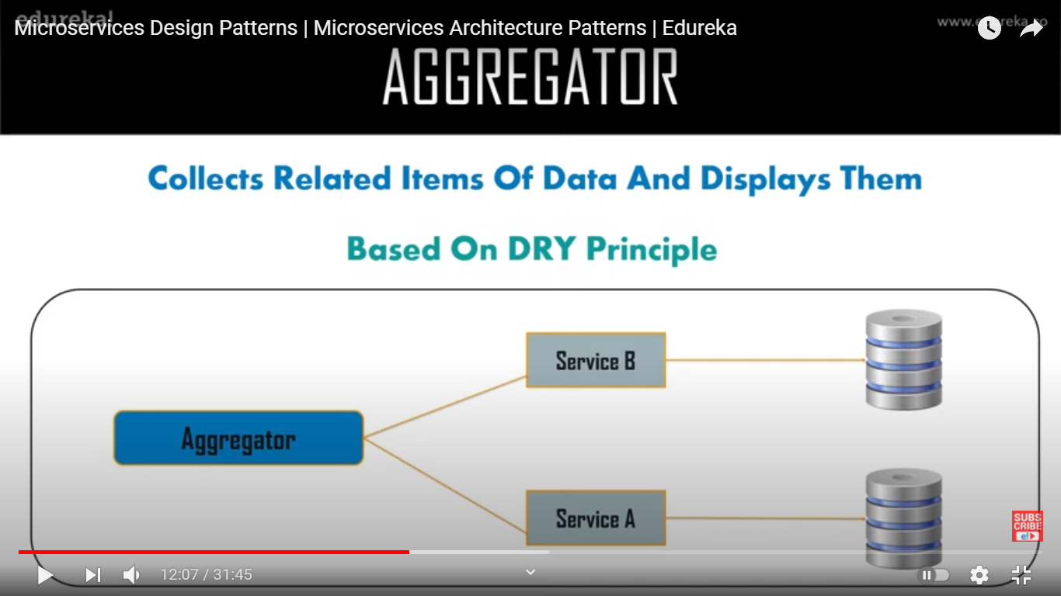

API Gateway
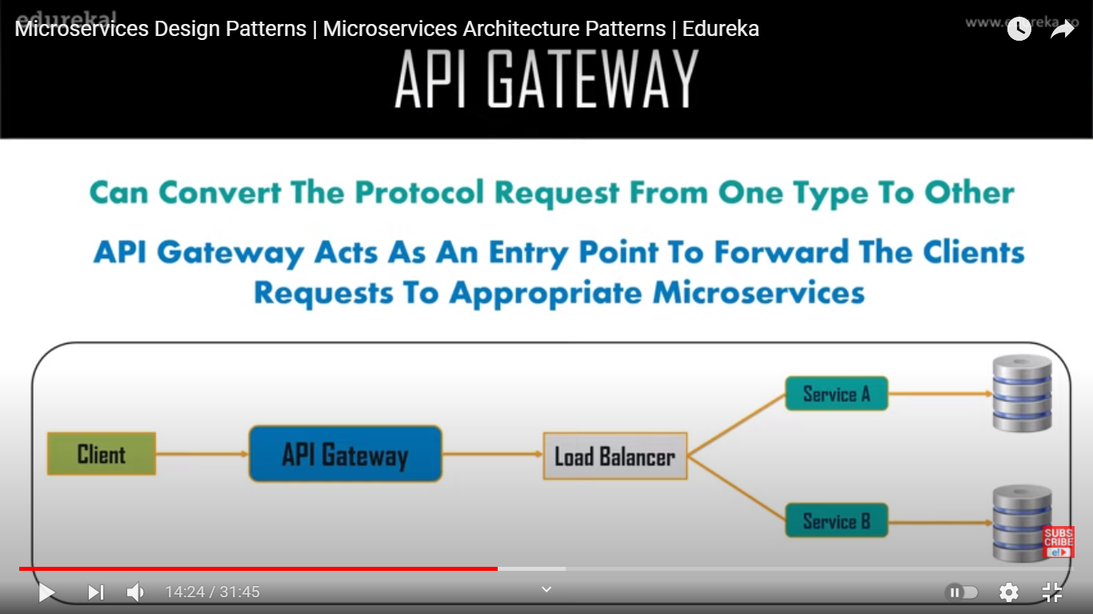

Chain of Responsibility

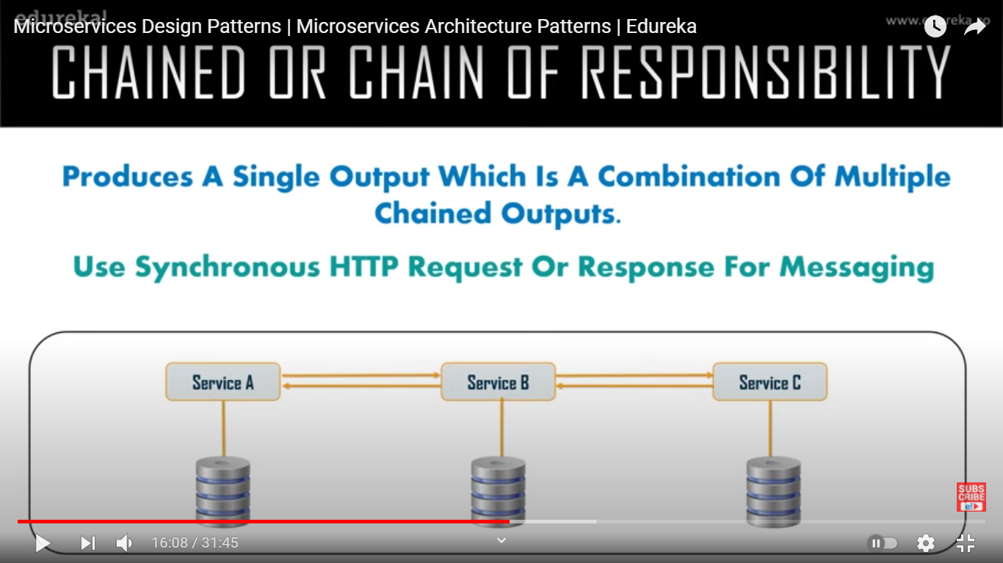

Asynchronous Messaging

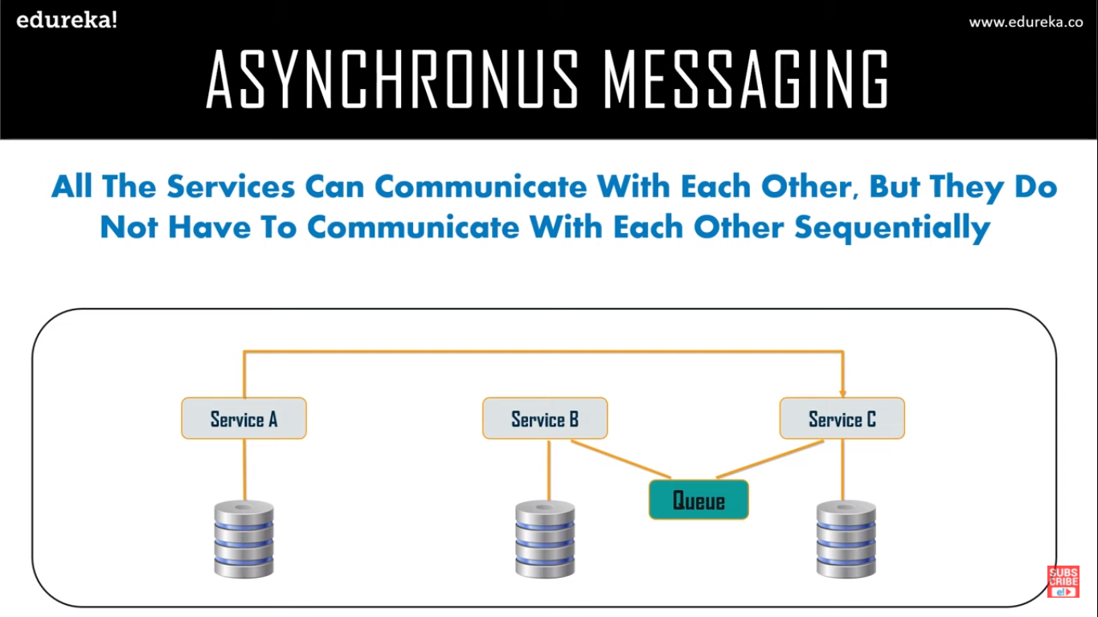

Database per service / or Share DB
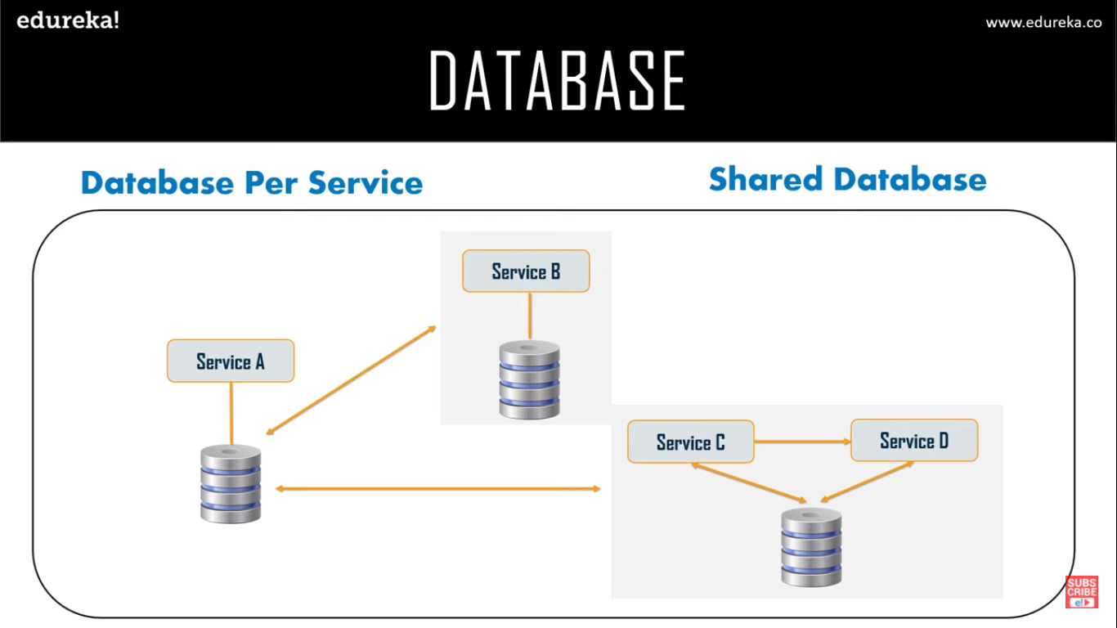

Event Sourcing
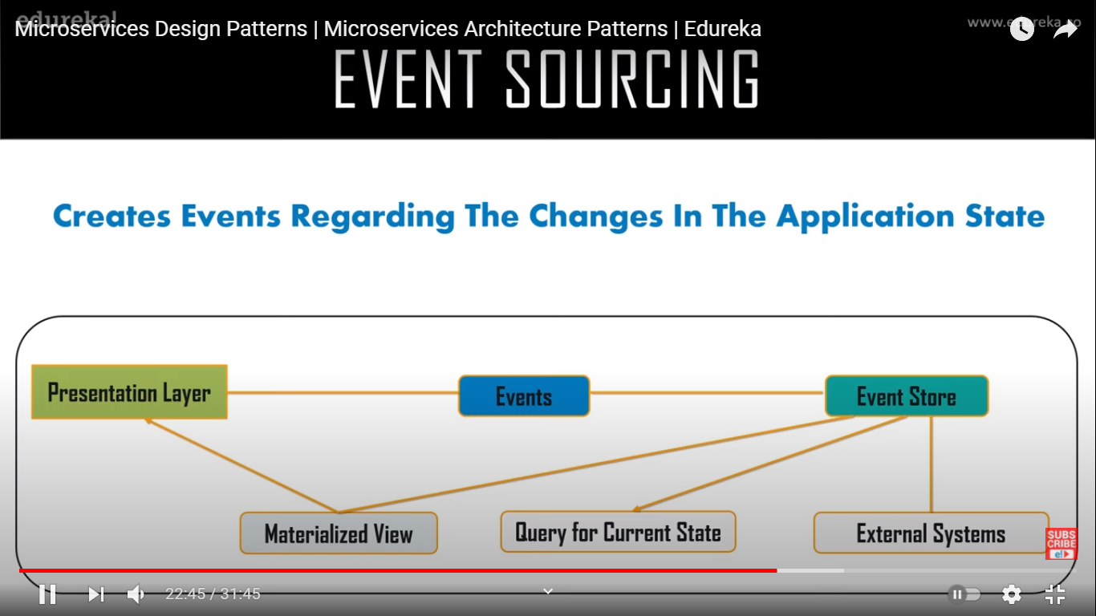

Branch Pattern : Process request from multiple
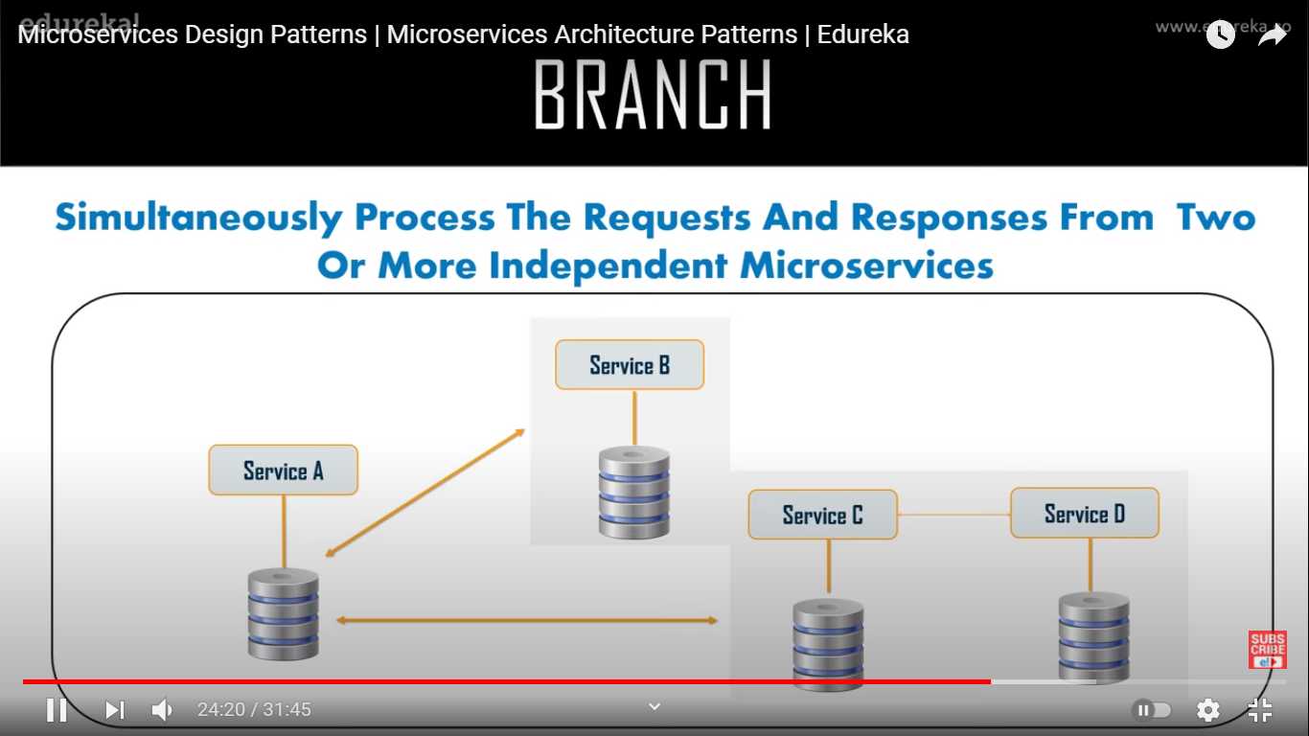

Command Query Responsibility Segregator CQRS
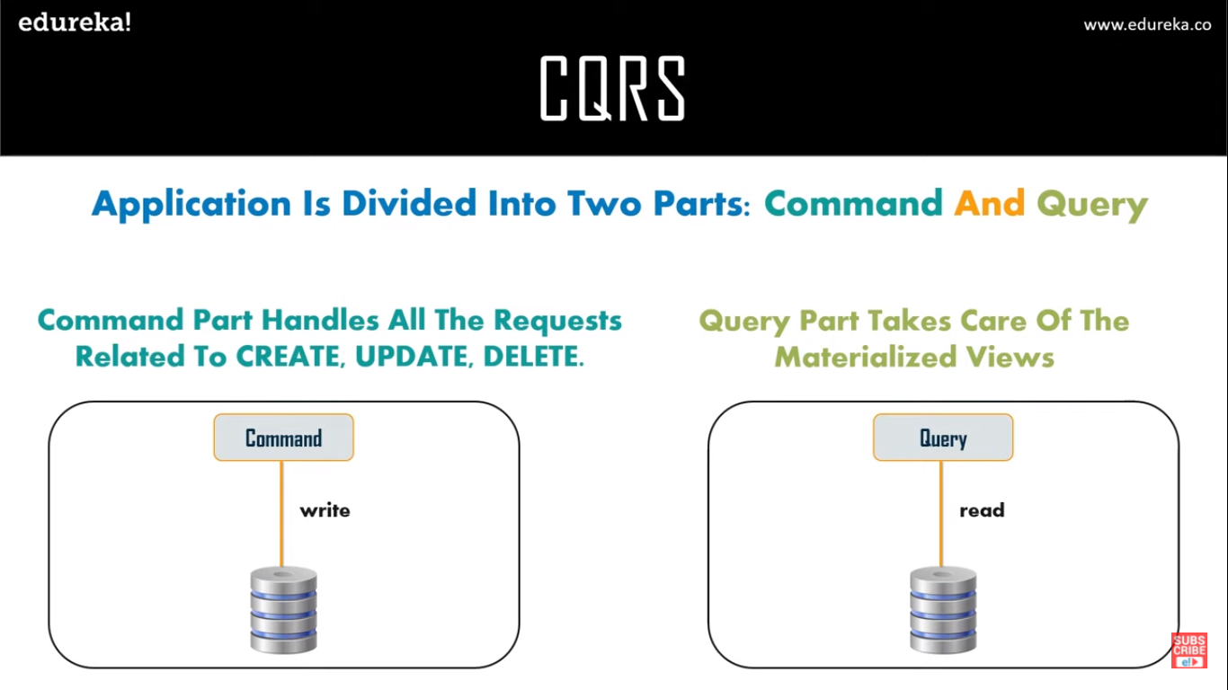

Circuit Breaker

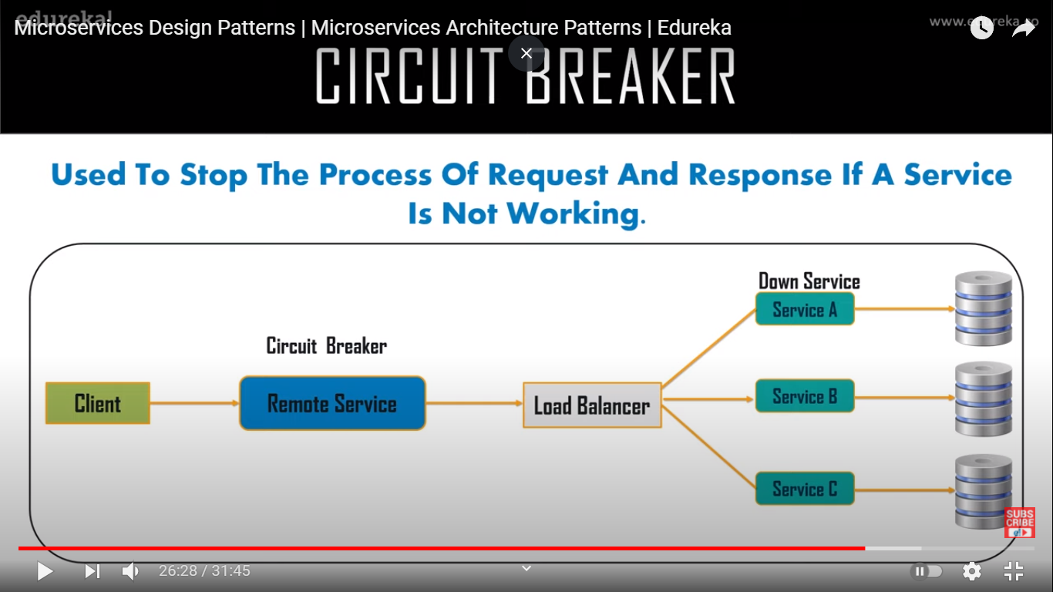
Fhjgj

Decomposition Pattern

